**Things To Think About When Disposing Of Old Cell Phones**

We are so fascinated with advances in information technology that only a tiny percentage of individuals consider the effects of electronic devices on the environment. Furthermore, the various advantages of mobile phones make our lives easier, and once these gadgets have served their purpose, they are discarded. Each IT gadget includes potentially hazardous chemicals, thus we must exercise caution while Disposing Of Old Mobile Phones.

In this article, I'll show you how to dispose of old phones in the most effective and environmentally friendly way possible.

**Why should I think about getting rid of my old cellphones?**

The disposal of industrial and residential equipment, as well as cell phones, requires legal oversight.

Plastic makes up our cell phones, which can take hundreds of years to degrade. Furthermore, precious metals such as palladium, gold, copper, and silver are found on the electrical boards of these devices.

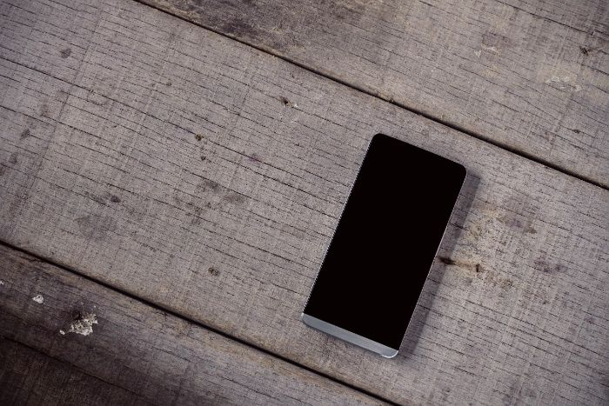

Environmentalists believe the mobile battery to be the most hazardous component of cell phones. It's made up of:

* Chromium
* Cadmium
* Lead
* Lithium
* Nickel

It's worth noting that these compounds pose a significant risk to human health because they may readily damage soil and groundwater on a large scale.

As a result, we all have a common obligation to think about sustainable disposal solutions.

**Who is responsible for the disposal of cell phones and batteries?**

Mobile phones are recycled by a large number of businesses in this industry. Companies inadvertently contribute to the accumulation of outmoded equipment in today's world, and various IT gadgets end up in landfills, badly impacting the environment and posing a serious threat to humanity. As a result, phone companies have started recycling programmes for their products.

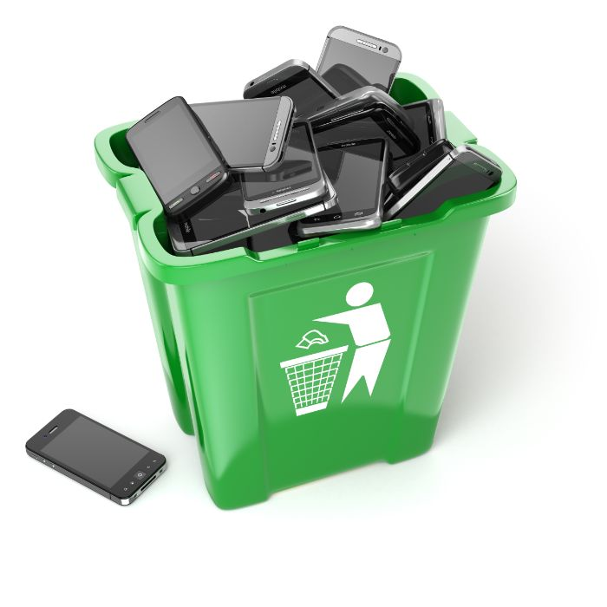

Panasonic, Siemens, Samsung, Sony Ericsson, Apple, LG, and Nokia are the most active collectors. These companies set up collection facilities in various locations to assist clients in getting rid of their old phones. The technique is simple: retail malls in major cities put special bins to collect old phones.

Many businesses effectively accept not only old but even defective mobile phones and provide substantial discounts on the purchase of a new model.

Eldorado is actively working in this area; the business has had campaigns in the past to provide discounts and swap items.

The mobile phone may also be given to Mobile Recycling Companies since it includes plastic, metal, and precious metals.

The recycling process is time-consuming and involves multiple phases. It can only be carried out by a business with a specific material base and the appropriate experience in this industry.

**Disposal of Cellular and Mobile Phones**

Old phones are collected by IT recycling firms based on a set of criteria. After that, the tedious process of manual deconstruction into components begins (case, battery, electronic board).

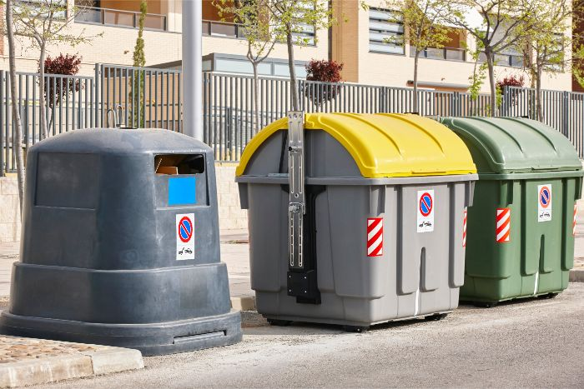

Furthermore, batteries cannot be burned. As a result, they are classified as a first-class danger and produce toxins and poisons during burning. As a result, IT Disposal Companies disassemble it into its component pieces, removing the electrolyte, separating the anodes and cathodes, and remelting the metal and plastic parts. This is also a time-consuming and expensive operation.

**In other nations, how do you recycle cell phones?**

**What Should You Do With Your Old Cell Phones?** Technological advancement has resulted in amazing increases in the proportion of electronics and equipment in our surroundings, and their constant development has resulted in the accumulation of a huge number of outdated models in landfills, posing a serious environmental concern.

A mobile phone is one of the most ubiquitous electronics. In several nations, it is used by more over 90% of the population. However, its extensive dissemination did not raise awareness of the necessity to Dispose Of Old Mobile Phones among the general public.

According to statistics, just 3% of the population donates their cellphones for recycling, with the majority disposing of them in the garbage or storing them on shelves at home.

**USA**

The problem of recycling in the United States has been handled by the implementation of a nationwide programme aimed at collecting obsolete equipment. IT Recycling centres have been established for the general public, with a portion of the revenues going to charity.

**UK**

Apple accepts damaged and old models of its goods for scrap in the United Kingdom and pays money for them.

**Germany**

Germany has a unique approach to environmental protection. To urge people to Dispose Of Old Mobile Phones, they estimate that 90% of the population utilises cellular communications.

Many rich nations collect obsolete but functional phone models and donate them to African countries as philanthropic help.

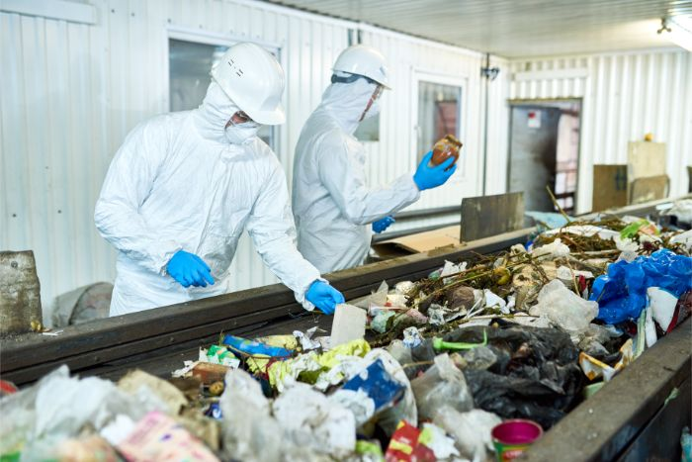

In any event, the strategy should be beneficial rather than harmful. If your phone is no longer functional, you should simply send it over to an IT recycling company because this allows you to:

* Protect the environment against pollution, as well as mankind from a variety of illnesses.